MODULE: 14 | LESSON: 2 | POLYGONS IN THE COORDINATE PLANE

Polygons are formed from three or more points, called vertices, that are connected by line segments and that enclose an area.  If the lengths of the sides are known, the area and perimeter of a polygon can be found. They can also be found if the coordinates of the vertices are known. |  | 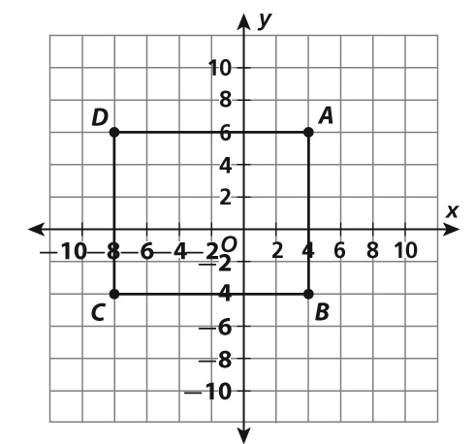
Find the Perimeter  First, identify the coordinates of the points that form the vertices of the polygon.  A: (4, 6); B: (4, 4); C: (8, 4); D: (8, 6)  Next, find the lengths of the sides.  AB  10 units  BC  12 units  CD  10 units  DA  12 units  Finally, add the lengths of the sides.  10  12  10  12  44  The perimeter of the polygon is 44 units. | Find the Area  First, identify the polygon. The figure is a rectangle, so its area is the product of its length and width.  Next, use the coordinates of the points to find the length and width.  AB  10 units  BC  12 units  Finally, multiply the length and width.  10 × 12  120  The area of the polygon is 120 square units.  In this case, the area can also be found  by counting the squares enclosed by the polygon. There are 30 squares.  How much area is represented by each square? 2 × 2, or 4 square units.  The area is 30 cubes × 4, or 120 square units.

